Supplementary Information of

Quantification of HAXPES: Calculating Relative Sensitivity Factors for 1.5 keV - 10 keV Photons and any Instrument Geometry

By David J H Cant*, Ben F Spencer, Wendy R Flavell and Alexander G Shard

# Plots of asymmetry parameters and modelled data for selected peaks

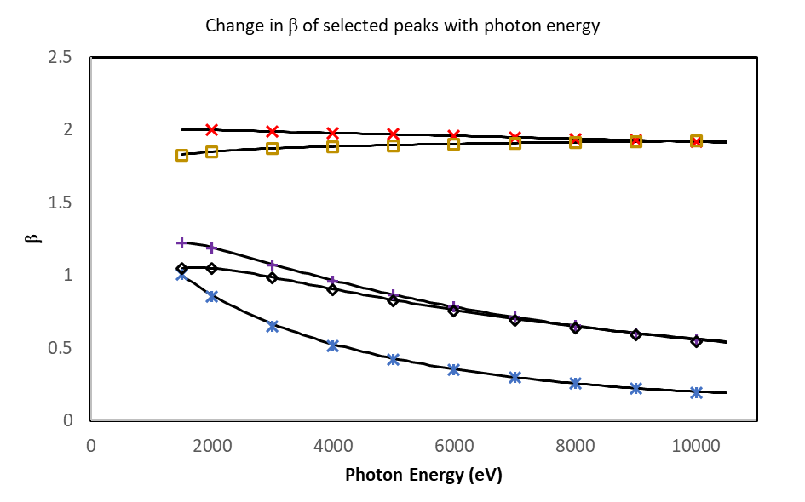

Figure S1 - b values from Trzhaskovskaya and Yarzhemsky[1], [2] for selected subshells. Values from the database are shown as points, the descriptive curves in this paper are shown as lines. b values for *s* shells are typically very close to 2, so only the Si 1*s* and Au 4*s* are shown as examples. Markers correspond to subshells as follows: (**🞨** - Si 1*s*); (**🞶** - Si 2*p* 3/2); (**🞡** - Ag 3*d* 5/2); (**□** - Au 4*s*); (**◇** - Au 4*f* 7/2).

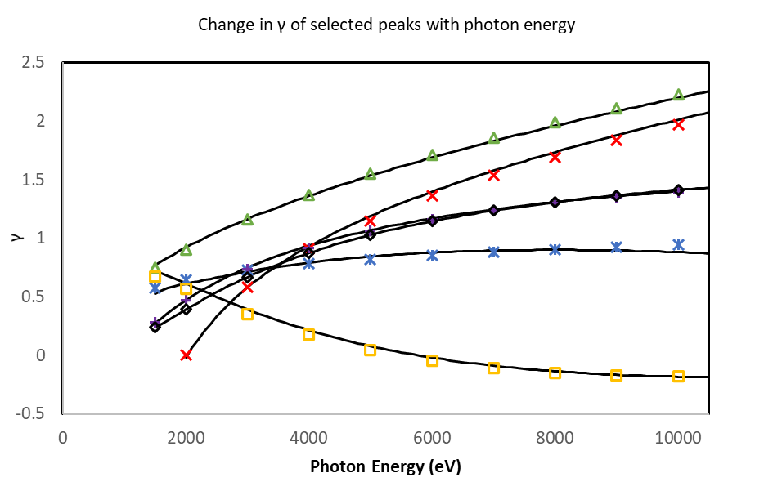

Figure S2 - g values from Trzhaskovskaya and Yarzhemsky[1], [2] for selected subshells. Values from the database are shown as points, the descriptive curves in this paper are shown as lines. Markers correspond to subshells as follows: (**△** - C 1s); (**🞨** - Si 1*s*); (**🞶** - Si 2*p* 3/2); (**🞡** - Ag 3*d* 5/2); (**□** - Au 4*s*); (**◇** - Au 4*f* 7/2).

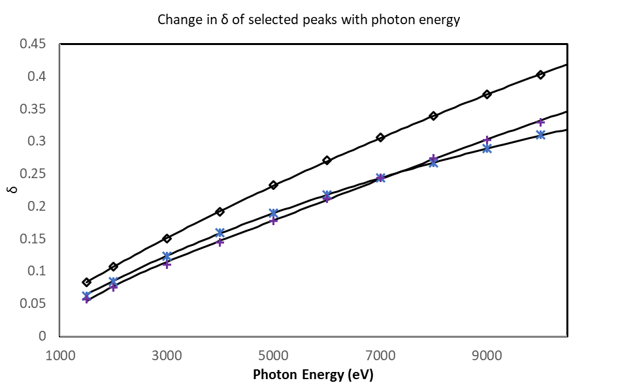

Figure S - d values from Trzhaskovskaya and Yarzhemsky[1], [2] for selected subshells. Values from the database are shown as points, the descriptive curves in this paper are shown as lines. Markers correspond to subshells as follows: (**🞶** - Si 2*p* 3/2); (**🞡** - Ag 3*d* 5/2); (**◇** - Au 4*f* 7/2).

# Plots of model deviation from database values for asymmetry parameters

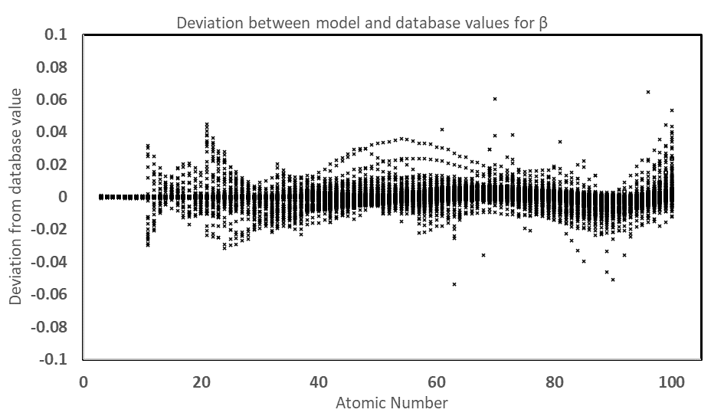

Figure S4 - Plot of the deviation between modelled values of b and database values.

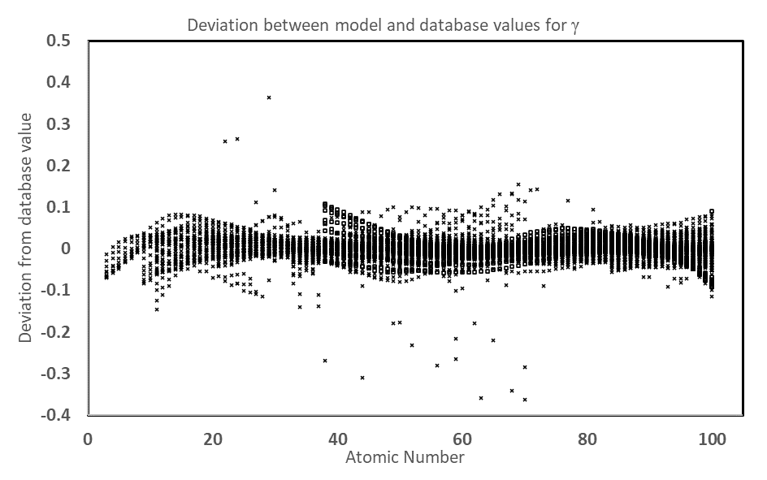

Figure S5 - Plot of the deviation between modelled values of g and database values.

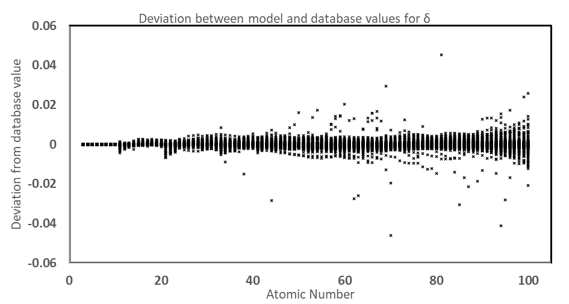

Figure S - Plot of the deviation between modelled values of δ and database values.

# References

[1] M. B. Trzhaskovskaya and V. G. Yarzhemsky, “Dirac–Fock photoionization parameters for HAXPES applications,” *At. Data Nucl. Data Tables*, vol. 119, pp. 99–174, Jan. 2018, doi: 10.1016/J.ADT.2017.04.003.

[2] M. B. Trzhaskovskaya and V. G. Yarzhemsky, “Dirac–Fock photoionization parameters for HAXPES applications, Part II: Inner atomic shells,” *At. Data Nucl. Data Tables*, vol. 129–130, p. 101280, Sep. 2019, doi: 10.1016/J.ADT.2019.05.001.